**Gen AI Bootcamp 2025 – Repository Creation Journal**

**1. Overview**

**This journal details the step-by-step process of creating the gen-ai-bootcamp-2025 repository on GitHub, including proof of work, challenges faced, and solutions applied.**

**2. Steps Taken**

**Step 1: Created a GitHub Account**

* **Navigated to** [**GitHub**](https://github.com/)
* **Clicked Sign Up and used the following details:** 
  + **Email:** [**missionworkuk@gmail.com**](mailto:missionworkuk@gmail.com)
  + **Username: karl247ai**
* **Completed email verification and set up the profile.**

**✅ Proof of Work:  
🖼️ *(Insert a screenshot of the GitHub account creation confirmation here. Please note that the screenshot was taken after the repository was created)***

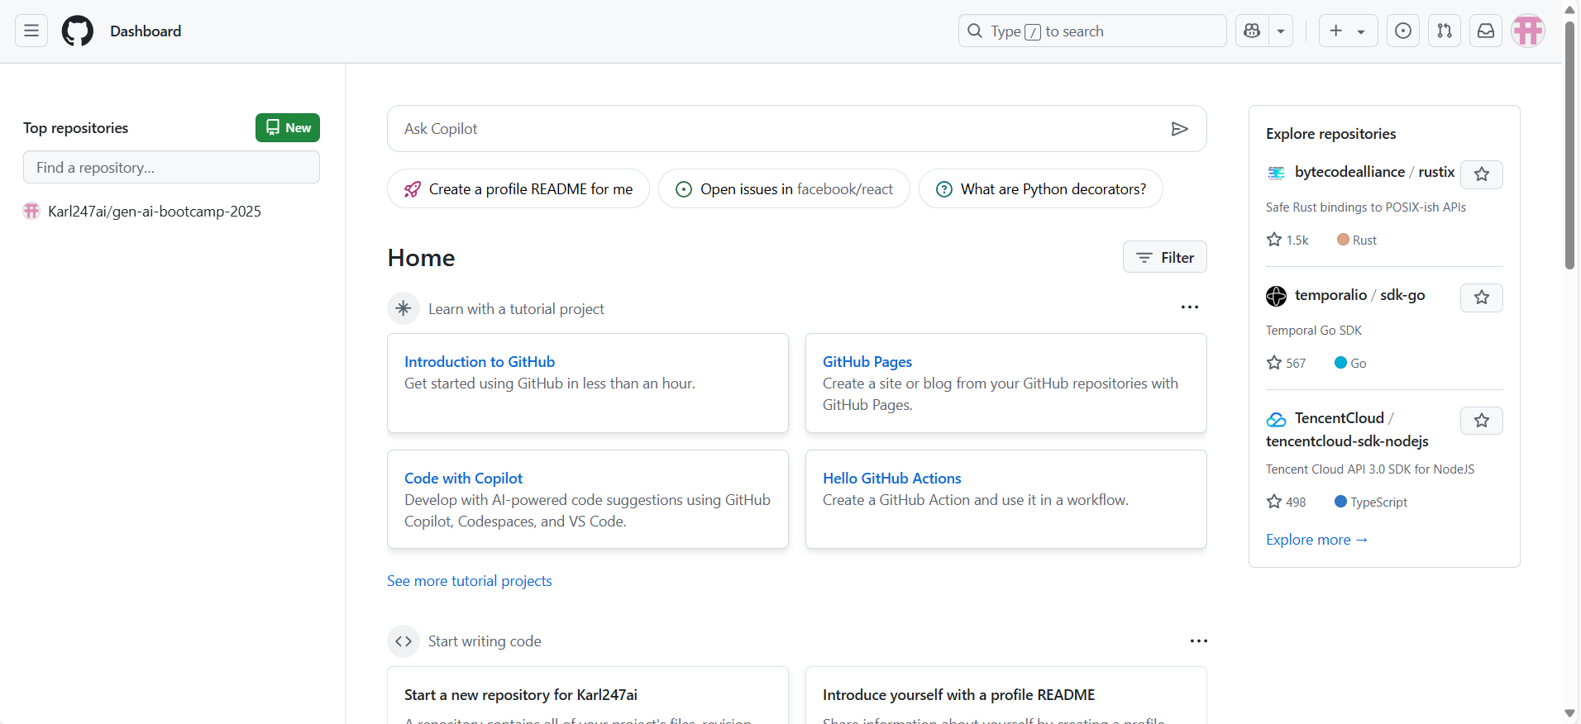

**Step 2: Created a Public Repository on GitHub**

* **Logged into GitHub**
* **Clicked on New Repository**
* **Named it exactly: gen-ai-bootcamp-2025**
* **Set visibility to Public**
* **Clicked Create Repository**

**✅ Proof of Work:  
🔗** [**Link to Repository**](https://github.com/Karl247ai/gen-ai-bootcamp-2025) **🖼️ *(Insert a screenshot of the repository creation page here)***

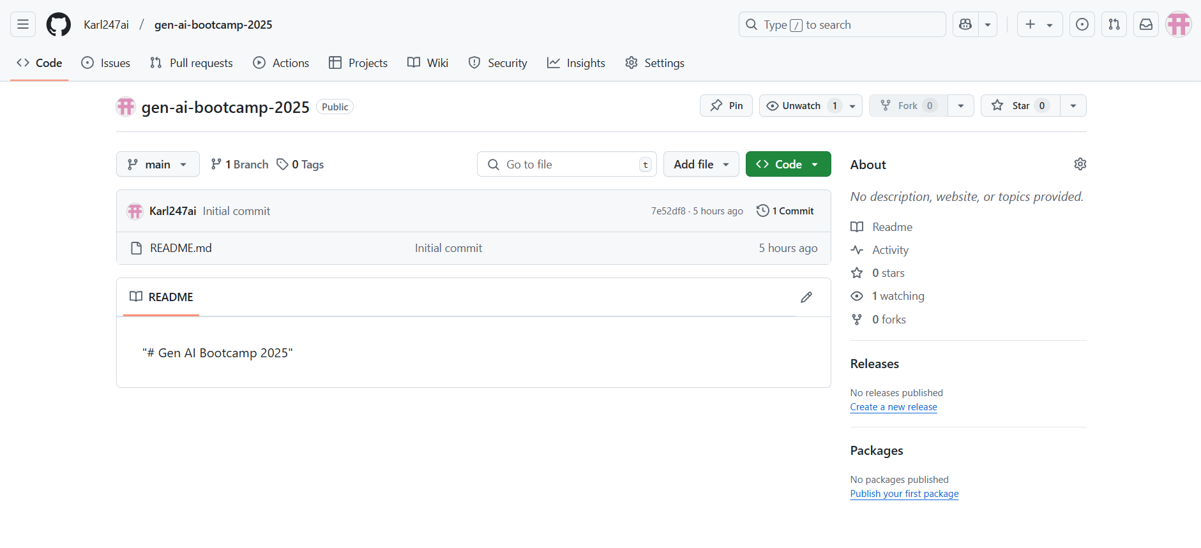

**Step 3: Installed Git on Windows**

* **Downloaded Git for Windows from** [**git-scm.com**](https://git-scm.com/)
* **Installed it with default settings**
* **Verified installation using:**
* **git --version**

**✅ Proof of Work:  
🖼️ *(Insert a screenshot of Git installation verification here)***

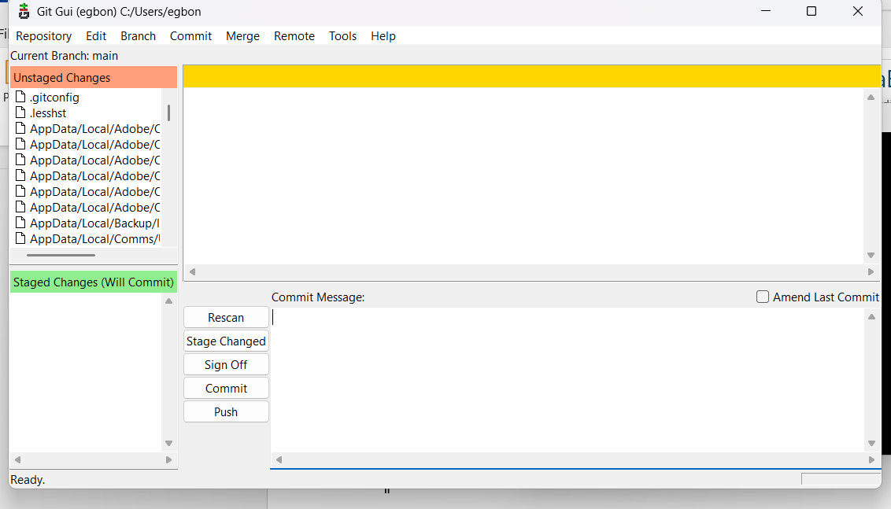

**Step 4: Set Up Local Repository**

* **Opened PowerShell and ran:**
* **cd C:\Users\egbon # Change to user directory**
* **git init # Initialize Git**
* **Added the remote repository:**
* **git remote add origin https://github.com/Karl247ai/gen-ai-bootcamp-2025.git**

**✅ Proof of Work:  
🖼️ *(Insert PowerShell terminal output here)***

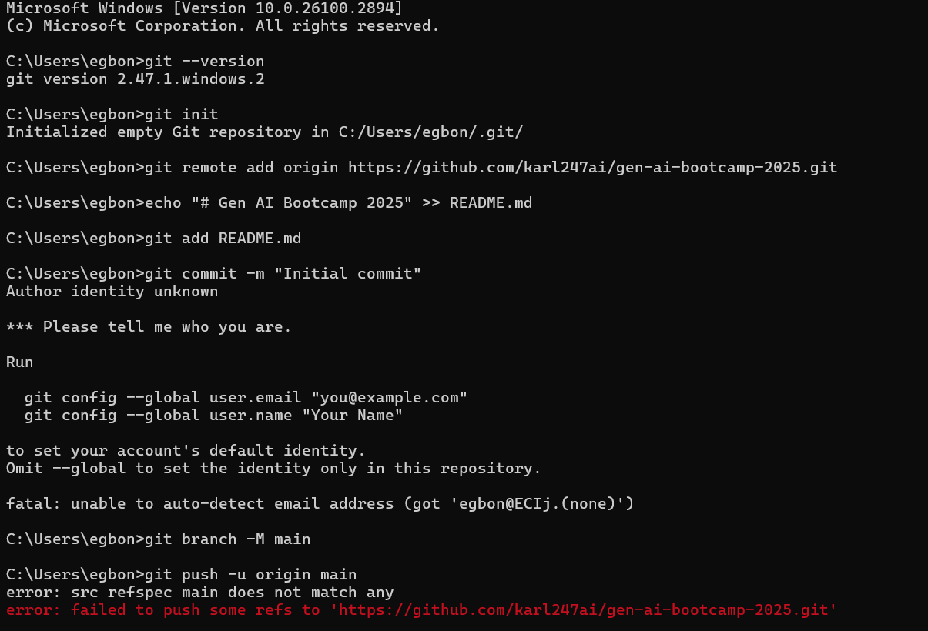

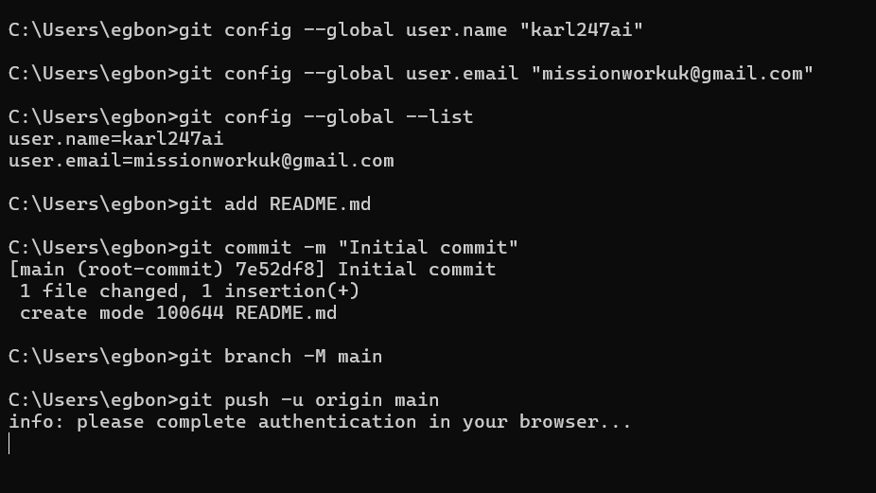

**Step 5: Committed Initial Changes**

* **Created a README file separately (not initialized with repository).**
* **Staged and committed the file:**
* **git add README.md**
* **git commit -m "Initial commit"**

**✅ Proof of Work:  
🖼️ *(Insert commit confirmation screenshot here)***

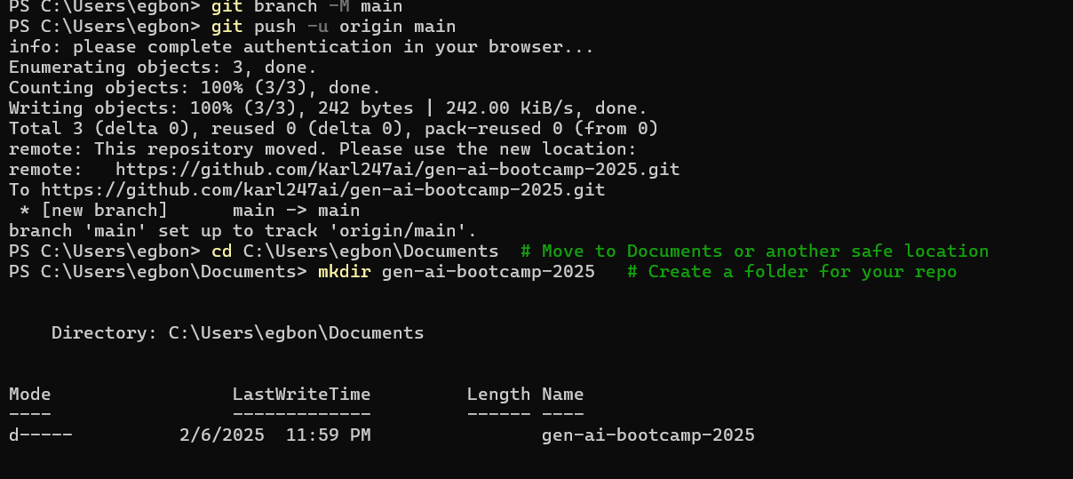

**Step 6: Fixed Errors & Challenges Faced**

* **Issue 1: "git is not recognized as an internal or external command"** 
  + **Solution: Installed Git and restarted PowerShell**
* **Issue 2: "remote origin already exists"** 
  + **Solution: Removed the existing origin and re-added it**
* **git remote remove origin**
* **git remote add origin https://github.com/Karl247ai/gen-ai-bootcamp-2025.git**
* **Issue 3: "Author identity unknown"** 
  + **Solution: Configured Git user identity**
* **git config --global user.name "Karl247AI"**
* **git config --global user.email "missionworkuk@gmail.com"**

**✅ Proof of Work:  
🖼️ *(Insert terminal output fixing these issues)***

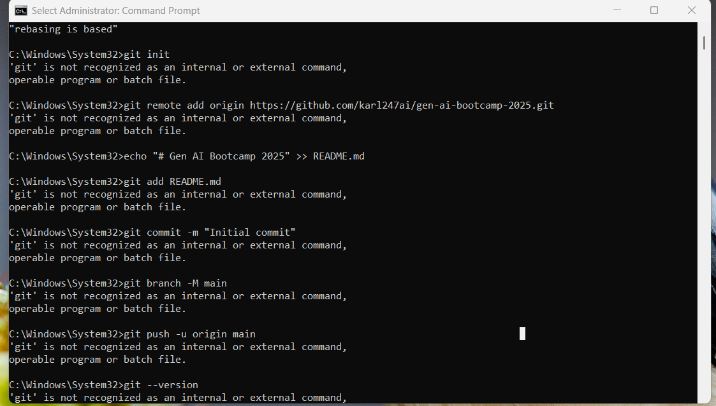

**Step 7: Successfully Pushed to GitHub**

* **Renamed branch to main:**
* **git branch -M main**
* **Pushed code to GitHub:**
* **git push -u origin main**

**✅ Proof of Work:  
🔗** [**GitHub Repository**](https://github.com/Karl247ai/gen-ai-bootcamp-2025) **🖼️ *(Insert successful push confirmation screenshot here)***



**3. Lessons Learned**

* **Understanding Git & GitHub workflow**
* **Fixing common Git errors**
* **Importance of documentation & version control**